Georgia on my Mind
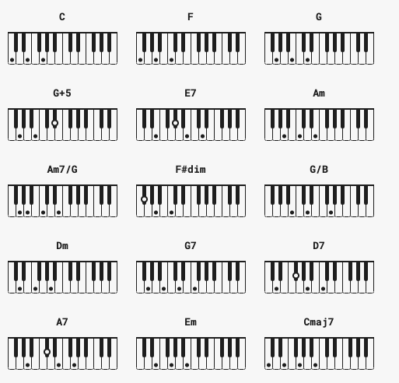

C F C G G+5

[Verse 1]
C E7 Am Am7/G F F#dim
Georgia,Georgia,the whole day through.
C G/B Am
Just an old---sweet song,
Dm G7 C F C G+5
keeps Georgia on my mind.

[Verse 2]
C E7 Am Am7/G F F#dim
Georgia, Georgia, a song of you,
C Am Dm
Comes as sweet and clear
G7 C F C E7
as moonlight through the pines.

[Chorus]
Am F Am F
Other arms reach out to me;
Page 1/2
Am F C D7
Other eyes smile tenderly.
Am F C A7
Still in peaceful dreams I see,
Dm G G+5
The road leads back to you.

[Instrumental Break]

[Chorus]
Am F Am F
Other arms reach out to me;
Am F C D7
Other eyes smile tenderly.
Am F C A7
Still in peaceful dreams I see,
Dm G G+5
The road leads back to you.

[Verse 3]
C E7 Am Am7/G F F#dim
Georgia, Georgia, no peace I find.
C Am Dm
Just an old sweet song
G7 C F Em Dm C Cmaj7
Keeps Georgia on my mind.

Georgia on my Mind

C E7 Am Am7 F Fm
Georgia,Georgia,the whole day through.

C G Am
Just an old---sweet song,

Dm G7 C F C G
keeps Georgia on my mind.

C E7 Am Am7 F Fm
Georgia, Georgia, a song of you,

C Am Dm
Comes as sweet and clear

G7 C F C E7
as moonlight through the pines.

Am F Am F
Other arms reach out to me;

Am F C D7
Other eyes smile tenderly.

Am F C A7
Still in peaceful dreams I see,

Dm G G+5
The road leads back to you.

[Instrumental Break]

Am F Am F
Other arms reach out to me;

Am F C D7
Other eyes smile tenderly.

Am F C A7
Still in peaceful dreams I see,
Dm G
The road leads back to you.

C E7 Am Am7 F Fm
Georgia, Georgia, no peace I find.

C Am Dm
Just an old sweet song

G7 C F Em Dm C Cmaj7
Keeps Georgia on my mind.

Georgia On My Mind

C E7 Am7 G7 F Fm
C A7 D7 G7 E7
A7 D7 G7

C E7 Am7 G7 F Fm
C A7 D7 G7 C
F C E7

BRIDGE
Am7 F Dsus2 F
Am7 F Am7 D7
Am7 F C A7
Dm7 G7

C E7 Am7 G7 F Fm
C A7 D7 G7 C
F C E7

Repeat BRIDGE
C E7 Am7 G7 F Fm
C A7 D7 G7 E7
A7 D7 G7
D7 G7 F Fm C
Fm C G7 C

